training_args = Seq2SeqTrainingArguments(

output_dir="./results",

eval_strategy="epoch",

learning_rate=5e-5,

per_device_train_batch_size=8,

per_device_eval_batch_size=8,

weight_decay=0.01,

save_total_limit=3,

num_train_epochs=6,

predict_with_generate=True,

fp16=True, # Use mixed precision training (if your GPU supports it)

report_to="tensorboard",

logging_dir="./logs",

)

{'eval_loss': 1.035720705986023, 'eval_model_preparation_time': 0.003, 'eval_bleu': 0.3355993666779775, 'eval_rouge1': 0.6767583744174921, 'eval_rouge2': 0.4709384526980172, 'eval_rougeL': 0.6573565658875855, 'eval_exact_match': 0.09758454106280193, 'eval_runtime': 228.979, 'eval_samples_per_second': 9.04, 'eval_steps_per_second': 1.131}

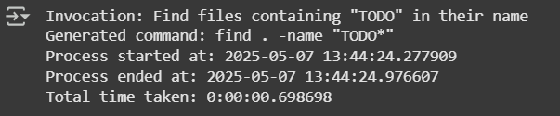

**For 6 epochs**

**For 10 epochs**

**training_args = Seq2SeqTrainingArguments(**

**output_dir="./results",**

**eval_strategy="epoch",**

**learning_rate=5e-5,**

**per_device_train_batch_size=8,**

**per_device_eval_batch_size=8,**

**weight_decay=0.01,**

**save_total_limit=3,**

**num_train_epochs=10,**

**predict_with_generate=True,**

**fp16=True, # Use mixed precision training (if your GPU supports it)**

**report_to="tensorboard",**

**logging_dir="./logs",**

**)**

{'eval_loss': 0.9577684998512268, 'eval_model_preparation_time': 0.0044, 'eval_bleu': 0.3603688455093338, 'eval_rouge1': 0.7023201503071155, 'eval_rouge2': 0.4992562044053831, 'eval_rougeL': 0.6818443200623971, 'eval_exact_match': 0.11835748792270531, 'eval_runtime': 222.2273, 'eval_samples_per_second': 9.315, 'eval_steps_per_second': 1.165}

